COSC2671: Social Media and Network Analysis
Assignment 1: Analysing and Tracking the Sentiment and Topics on Social Media
Author: Syeda Shabnam Khan (s4020189)

Introduction
In this report, we examine the subreddit GooglePixel. Google pixel is a mobile phone brand owned by Alphabet, the parent company that owns Google. The subreddit is dedicated to the company’s mobile devices. By extracting and analysing posts from this subreddit, we want to understand the following:
- The opinions and sentiments towards this brand.
- The trending concepts and topics associated with this brand.

Data Collection
We extracted 937 posts form the subreddit using the reddit API - Python Reddit API Wrapper (PRAW) (PRAW 7.7.1 documentation, n.d.). We used the hot function with limit set to 1000. However, we were only able to extract 937 posts with their title, description, time the post was created, reddit score and comment count. We modified the code from our workshop to achieve this and saved the data in a csv file.
Every time we called the API using the same parameters, the API returned one less post from the last call. Therefore, storing and reading data from csv made it easier during analysis.

Data Preprocessing and Exploration
Our dataset has 5 columns and 937 rows. We dropped the first row that contained links to different threads and worked with the remaining 936 posts. We merged the post titles with their descriptions and changed the post created time into date-time format.
Some posts had external links which were removed along with any punctuation using regex. Some of the codes were reused from COSC2820 workshops and assignments (RMIT, 2024). Next, we removed stop words and tokenized the posts. Then we lemmatized the words to root words. We did this to reduce the number of words from our corpus which will be the features for any machine learning algorithm we use ahead.
To get a general idea on our data set, we plotted a word cloud. This shows us which words are more prominent at this point in our analysis.
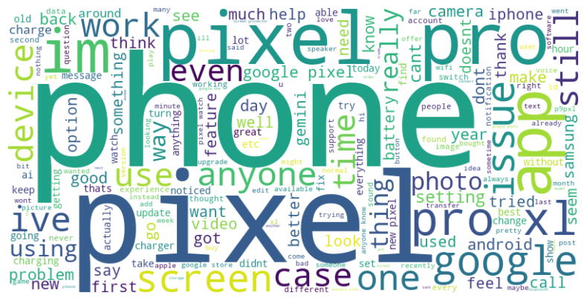
Fig 1: Word cloud of all posts
We can see those words like pixel, pro, phone occur very frequently. These are not very helpful in answering our research questions as these words are only reiterating the mane of the subreddit. We extracted bigrams and trigrams to see which words occur more frequently.
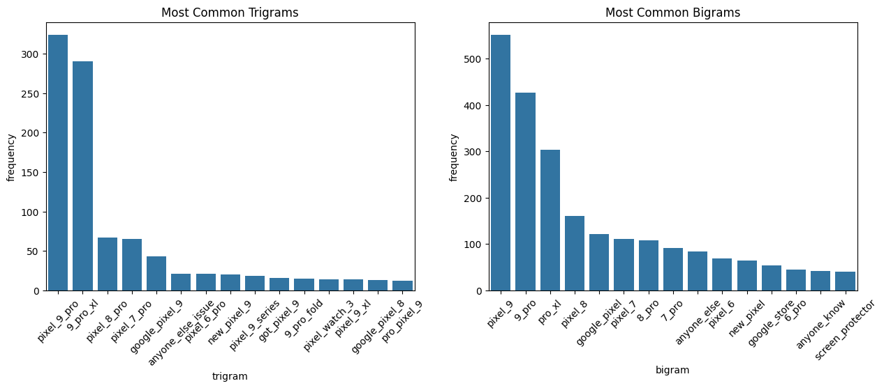
Fig 2: Most common trigrams and bigrams
From the two plots we can see very skewed graphs. This means some words appear together more often than others. There is some overlap between the bigrams and trigram words, such as pixel 9, 9 pro overlaps with pixel 9 pro. Given the domain knowledge about google pixel, the top 5 trigrams are more relevant.
We then looked at the frequency of the words and found that some of the more frequent words were again pixel, pro and 9. This is similar to our results from n-grams. Additionally, we noticed that between 5th and 6th most frequent words the frequency difference is relatively big. Therefore, we decided to remove the first most frequent words. This step also removes the top few n-grams due to overlap. We also removed the words that appeared only once in the entire corpus. We filtered out ‘im’, ‘ive’ and ‘dont’ that were not removed by the stop words. Finally, we have a list of clean tokens.

Method
We used sentiment analysis to answer the first research question. We used Valence Aware Dictionary and Sentiment Reasoner (VADER) for sentiment analysis. It is a lexicon and rule-based tool specifically tuned to opinions expressed in social media (Hutto, 2014.). We extracted the compound polarity score for each post and assigned labels (positive, negative or neutral) based on whether the score is greater than, less than or equal to zero.
For the second research question, we used Latent Dirichlet Allocation (LDA) from scikitlearn. We generated a bag of words using a count vectorizer. We set parameters such that the vectorizer ignores words that appear in over 95% of the documents. We have also set the minimum threshold to be 2. We wanted to extract 6 topics and used online learning where the model processes one document at a time.
We visualized the results using python seaborn, wordcloud and pyLDAvis libraries.

Findings
The findings show that our sample had more positive post compared to negative and neutral as illustrated in fig 3. 640 out of 936 posts were positive. There were 200 negative and 96 neutral posts.
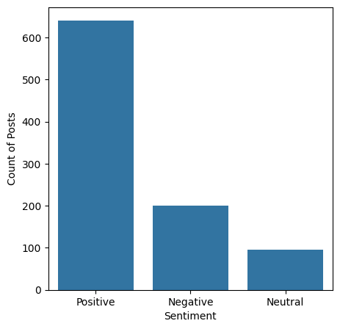
Fig 3: Frequency distribution of sentiments.
We further analysed the sentiments over different time units and reddit score. The plots in figure 4 illustrate interesting patterns. The data we extracted was posted between 26th August to 3rd September. The overall trend in this period shows a sharp peak of positive post on 27th August then a gradual decline, followed by a gradual rise. The plot against hours shows the posts made between 5pm and 6pm had a lot of negative sentiments.
Looking at the pattern of the sentiments over the days of week, we can see that sentiment scores peaked on Tuesday then gradually declined until Saturday, followed by another peak on Sunday. This almost replicates the plot of sentiment over date, which is expected given that the period spans over a week. To understand whether this is a recurring pattern we need to collect more samples over longer period of time.
Finally, plotting reddit scores (based on upvotes and downvotes) we can see that positive posts in general tend to have higher scores.

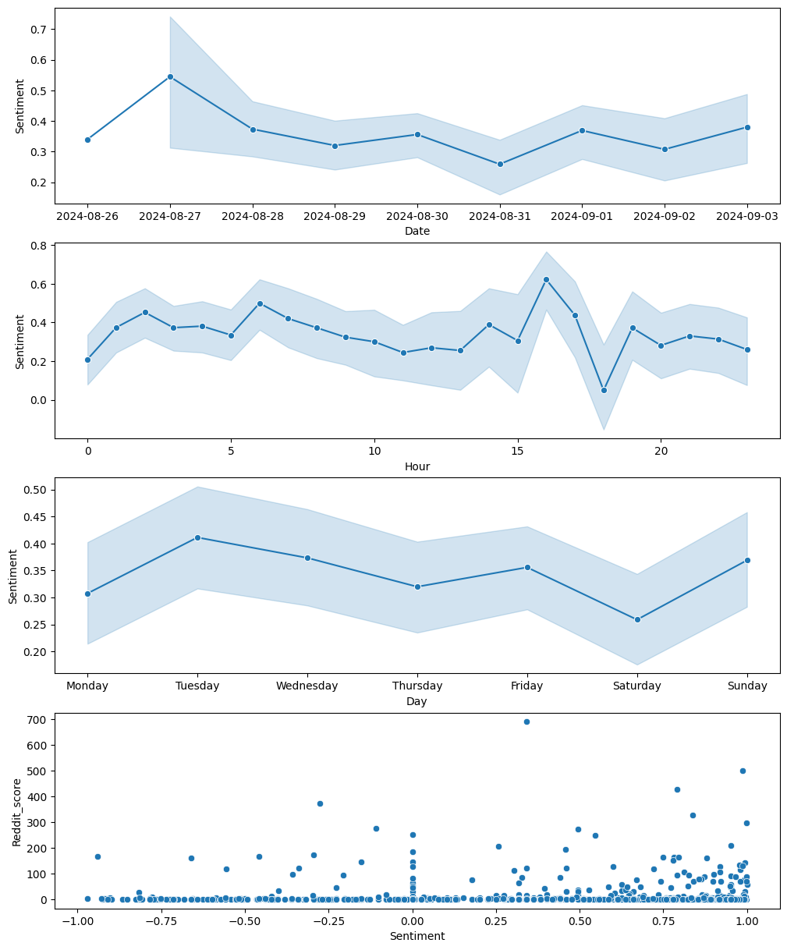
Fig 4: Sentiment scores by date, hour, day and reddit score.
In figure 5 we can see the inter topic distance. The circles represent topics and the bar chart shows the 30 most salient terms in the corpus. It is evident that the topics are distinct with no overlap.

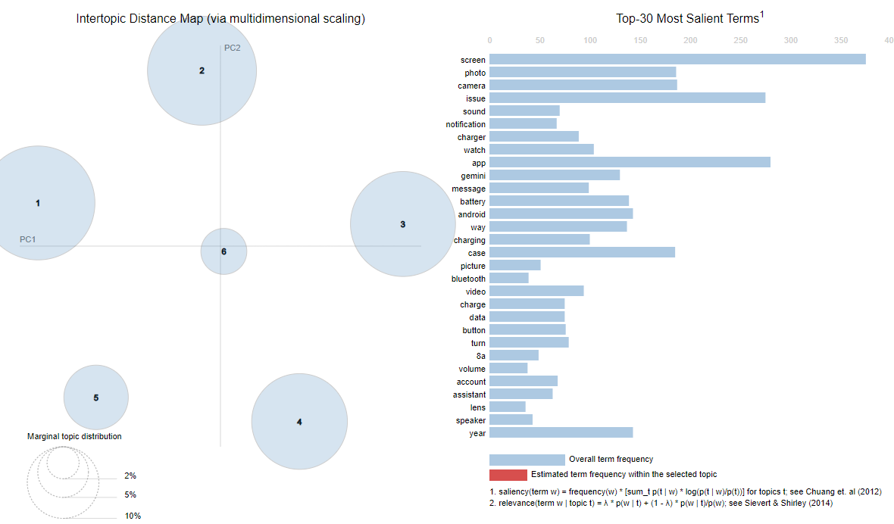
Fig 5: Inter topic distance map.
Figure 6 illustrates which words are more prominent in each topic through word cloud.
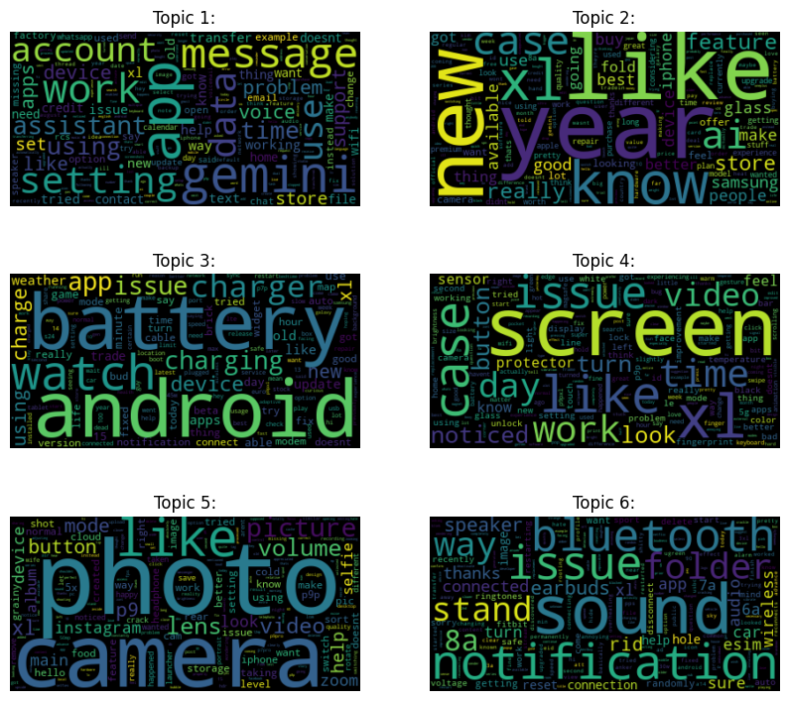
Fig 6: Word cloud for 6 topics.
Topic 1: It revolves around the built-in applications like message, setting and gemini.
Topic 2: This is associated with what the posters like in the brand.
Topic 3: It revolves around battery, watch charging and android, i.e., the features of the device.
Topic 4: This is about screen, case, video and look. This expresses opinions about the visual experience with the device.
Topic 5: this topic is all about the camera experience.
Topic 6: It is mostly focused on the sounds and audio experience.

Conclusion:
Based on our findings, the posts express positive sentiment towards the brand. A deeper dive into sentiment analysis against time shows that posts made between 5 and 6 P.M. tend to have more negative sentiment. Moreover, posts with positive sentiments are more highly rated in reddit. While this may be organic, it could also suggest moderation of posts within the community.
The trending topics associated with the brand are about the software and hardware features of the device such as battery, camera, screen and sound. Since the data we collected spans only over a period of a week, we were unable see how the topics evolve over time. Considering that the brand just launched a new product, analysing data before and after launch would have provided some interesting insights. However, due to the limitations of API, our data as well as analysis is limited.

References
Al-Serw, N. A.-R. (2021, February 19). Scraping Reddit using python Reddit API wrapper (PRAW). Analytics Vidhya. https://medium.com/analytics-vidhya/scraping-reddit-using-python-reddit-api-wrapper-praw-5c275e34a8f4
Hutto, C. J. (2014). vaderSentiment: VADER Sentiment Analysis. VADER (Valence Aware Dictionary and sEntiment Reasoner) is a lexicon and rule-based sentiment analysis tool that is specifically attuned to sentiments expressed in social media, and works well on texts from other domains. https://github.com/cjhutto/vaderSentiment
PRAW 7.7.1 documentation. (n.d.). Readthedocs.Io. Retrieved September 6, 2024, from https://praw.readthedocs.io/en/stable/
Python. (2019, September 5). GeeksforGeeks. https://www.geeksforgeeks.org/python-textblob-correct-method/
RMIT. (2024). COSC2671 Social Media and Network Analysis.
RMIT. (2024). COSC2820 Advance programming for Data Science.
(N.d.). Datacamp.com. Retrieved September 6, 2024, from https://www.datacamp.com/tutorial/stemming-lemmatization-python

